Myntra Fashion Clone
Project Documentation

Project Information
Field | Details
Project Name | Myntra Fashion Clone
Repository | https://github.com/pavanmani83090-design
Submitted By | T.PAVAN MANI KUMAR
Roll No | AV.SC.U4CSE25152
Course | User Interface Design (23CSE113), SEM-2
Submitted To | Dr. Rajkumar Batchu, Assistant Professor, CSE
Document Date | 19 May 2026

1. Project Overview
The Myntra Fashion Clone is a responsive frontend recreation of the popular Myntra e-commerce platform. The project focuses on creating a modern shopping interface with product browsing, filtering, cart management, wishlist functionality, and user account features. The website showcases advanced CSS layouts, JavaScript interactivity, responsive design principles, and a premium fashion retail experience. The clone includes a sticky navigation bar with search, product grid with dynamic filtering, detailed product modal, shopping cart with calculations, wishlist management, and user profile section.

Homepage View
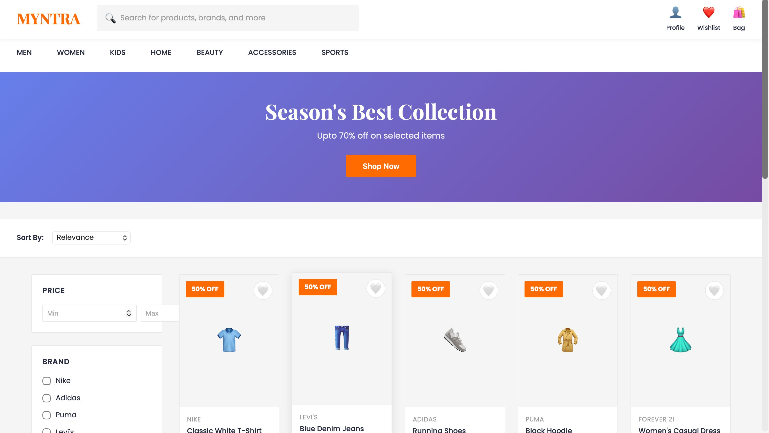
Figure 1: Myntra Clone - Homepage with product grid, filters, and navigation

2. Objectives
- Recreate the visual appearance and functionality of the Myntra e-commerce website.
- Design a responsive fashion retail shopping interface.
- Implement interactive product filtering and sorting mechanisms.
- Create shopping cart and wishlist management features.
- Showcase product details in modal views with size and color selection.
- Practice advanced CSS layouts, responsive design, and JavaScript functionality.
- Improve frontend development skills using HTML5, CSS3, and vanilla JavaScript.

3. Technology Stack
Technology | Purpose
HTML5 | Website structure, semantic markup, and content organization
CSS3 | Styling, layouts, animations, responsive design, and grid systems
JavaScript (Vanilla) | Interactive elements, filtering, cart management, and dynamic rendering
Google Fonts | Typography (Poppins, Playfair Display) and branding

4. Project Structure
myntra_clone/
├── myntra.html
├── styles.css (embedded)
├── script.js (embedded)
└── README.md

5. Main Features

5.1 Header & Navigation
- Sticky header with logo and branding
- Search bar with icon for product discovery
- Cart and wishlist buttons with item counters
- Profile section for user account access
- Responsive navigation layout

5.2 Navigation Bar
- Horizontal category navigation (MEN, WOMEN, KIDS, HOME, BEAUTY, ACCESSORIES, SPORTS)
- Active state highlighting
- Smooth hover transitions
- Category filtering capabilities

5.3 Banner Section
- Eye-catching promotional banner
- Gradient background (Purple to Blue)
- Call-to-action "Shop Now" button
- Responsive design with promotional text

5.4 Filters Section
- Price range filtering with Min/Max inputs
- Brand filter with checkboxes (Nike, Adidas, Puma, Levi's, etc.)
- Sort options (Relevance, Price Low-High, Price High-Low, Newest, Rating)
- Real-time product filtering

5.5 Product Grid
- Dynamic product cards with hover effects
- Product images with emoji placeholders
- Brand name and product name display
- Price display with original and discounted rates
- Discount percentage badge in orange
- Quick add to cart button
- Wishlist heart icon toggle

5.6 Sidebar Filters
- Category filter checkboxes
- Price range slider with Min/Max controls
- Rating filter (1-5 stars)
- Brand selection with multiple options
- Real-time filter updates

5.7 Product Modal
- Detailed product view in modal overlay
- Size selection options (XS, S, M, L, XL)
- Color selection with visual swatches
- Detailed product description
- Star rating and review count display
- Original price and discount percentage
- Add to Bag functionality
- Wishlist toggle button with heart icon

5.8 Shopping Cart
- Display all added items with product details
- Quantity adjustment controls (+/-)
- Item removal functionality
- Subtotal calculation
- Discount amount display
- Free delivery information
- Total amount display
- Checkout button

5.9 Wishlist
- Favorite items management
- Product grid view of wishlist items
- Quick add to cart from wishlist
- Remove from wishlist functionality

5.10 User Profile
- User account information display
- Order history section
- Settings and preferences management

Product Detail Modal
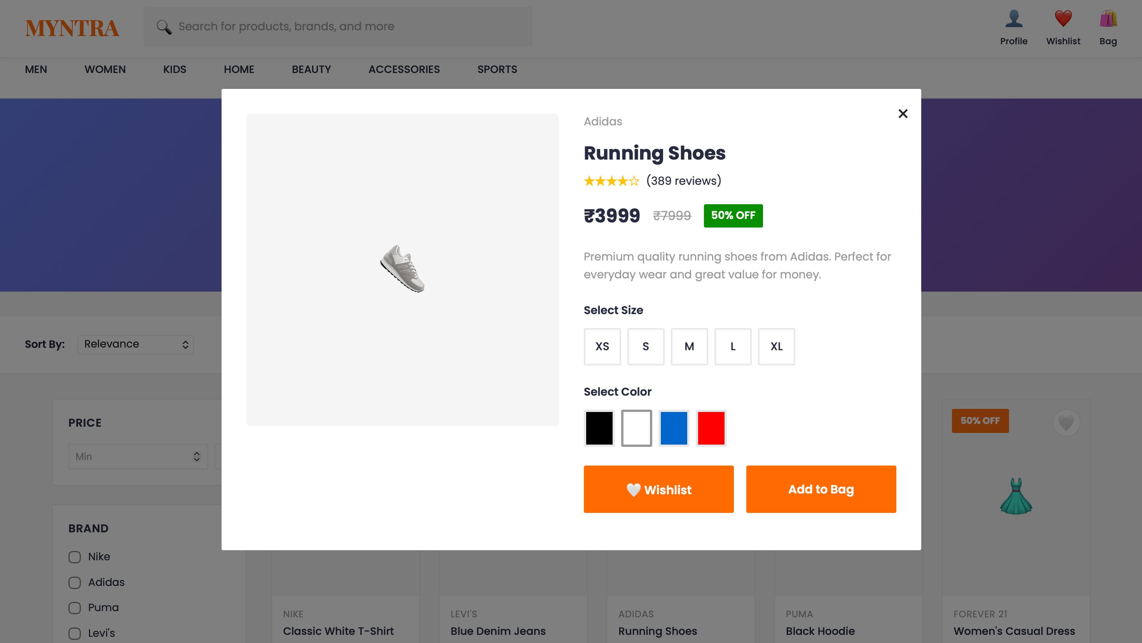
Figure 2: Product detail modal showing size, color selection, and pricing

6. Design Approach
The website follows Myntra's modern, user-friendly fashion e-commerce branding approach.

Typography
- Poppins
- Playfair Display

Color Palette
Color | Usage
Myntra Orange (#ff6b00) | Primary branding, buttons, and highlights
Dark Orange (#e55000) | Hover effects and active states
Dark Gray (#282c3f) | Main text and headings
Light Gray (#9b9b9b) | Secondary text and disabled states
White (#ffffff) | Background and card backgrounds

Layout Techniques
- Flexbox layouts for responsive navigation and headers
- CSS Grid for product grid layout
- Responsive card designs for product listings
- Modal overlays for detailed product views
- Sticky positioning for header persistence

7. Responsive Design
Device | Design Features
Desktop | Full navigation menus, multi-column product grid, sidebar filters, complete feature access
Tablet | Optimized grid layouts, adjusted spacing, responsive product cards, simplified filters
Mobile | Stacked layouts, hamburger menus, single-column product grid, touch-friendly buttons

Shopping Bag / Cart Page
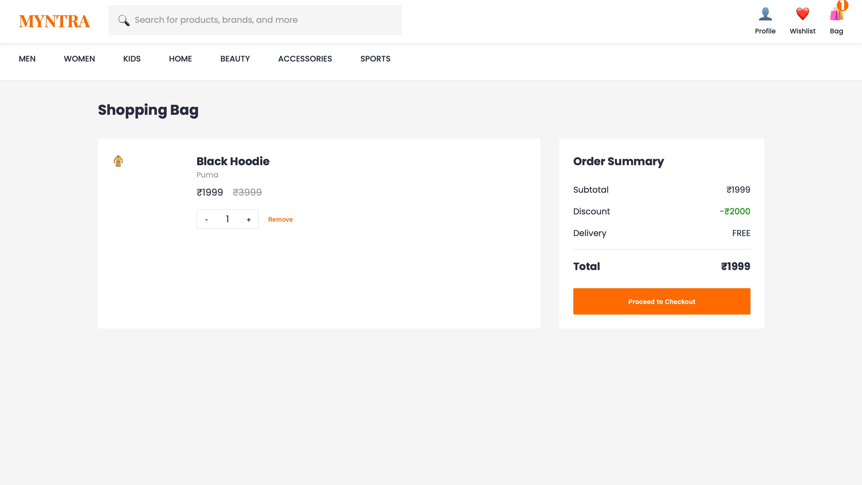
Figure 3: Shopping bag with order summary, quantity controls, and checkout

8. Learning Outcomes
- Mastered HTML5 semantic structuring for e-commerce layouts
- Advanced CSS Grid and Flexbox for responsive product grids
- JavaScript DOM manipulation and dynamic content rendering
- Implementation of filter and search functionality
- Shopping cart and wishlist state management using localStorage
- Modal windows and overlay implementations
- Responsive web design principles and mobile optimization
- E-commerce UI/UX design best practices
- JavaScript event handling and form interactions
- CSS animations and transitions for smooth user experience

9. Limitations
- Frontend-only implementation without backend server
- Product data is static and hardcoded
- No real payment gateway integration
- User authentication is not implemented
- No persistent database (uses localStorage only)
- No real-time inventory management
- Search functionality is basic string matching
- No order management system

10. Future Enhancements
- Backend integration with Node.js and Express
- Database implementation with MongoDB or PostgreSQL
- User authentication and authorization system
- Real payment gateway integration (Stripe, PayPal)
- Advanced search and AI-powered recommendations
- Order tracking and history management
- Admin dashboard for product management
- Real-time inventory system
- Progressive Web App (PWA) conversion
- Mobile app development with React Native

11. Conclusion
The Myntra Fashion Clone successfully demonstrates modern frontend development techniques through a comprehensive e-commerce interface. The project showcases responsive design, interactive shopping features, dynamic content filtering, state management, and a polished user experience while closely resembling a professional fashion retail platform. This project has significantly improved frontend development skills and provides a solid foundation for building full-stack e-commerce applications.

